West Hull Ladies
RRC

May Newsletter
Marathon Edition

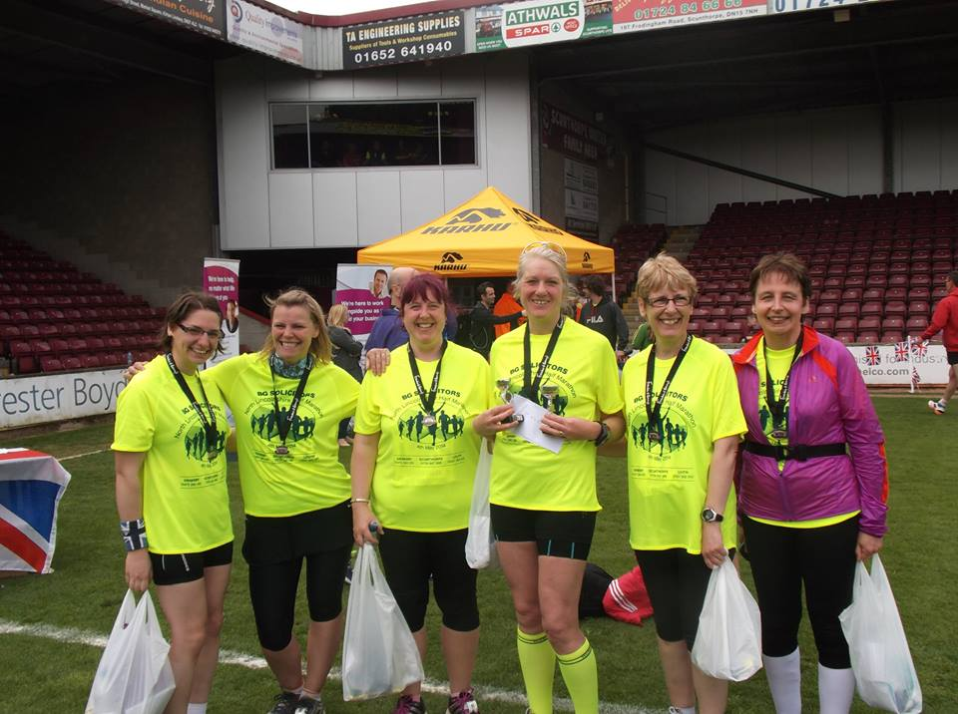

West Hull Ladies


WEST HULL LADIES RRC
COMMITTEE MEETING

Minutes 12th May 2014

Present Ann, Jill. Zoe, Maria, Linda, Andrea, Sandra, Sally, Beverley, Dian.Amanda

Prior to the meeting starting we were joined by Phil Haskins and Adam Hardy who gave an insight into how they proposed to bring a Marathon to Hull. The event was in the early stages of planning but they wanted local input about the route they had devised. If the Marathon went ahead the date would be in September 2015 but that was still open to change.
They thanked us for the input given and Maria was nominated to provide cakes for all finishers!

The meeting then began

- Apologies were received from Lisa, Debbie, Annette, Rachael.
- The minutes of the previous meeting were approved.
- It was confirmed that the Club Membership form had been amended, Debbie had sorted the questionnaire. North Lincs Marathon would not now go ahead until such time as they (Tape2Tape) felt it was right and they could do it successfully. The Humber Runner evening had been successful and the committee wished to pass on their thanks to Rachael for organising this. Rachael to organise another event possibly later this year and when we do the beginners course in 2015 about 3 weeks into that.
- LiRF courses. Amanda spoke about this and it was felt that we should try and obtain bursaries’ for 2 other persons to complete these courses. The next course to be held in July at the University. ACTION – Amanda to contact HAN re funding and to contact 2 ladies nominated by the Committee.
- Nominations wanted to take on the role as liaison officer for attending the HAN meetings. No volunteers at this point but after the meeting Linda and Maria did volunteer to carry this out. Thanks from the Committee to both ladies.
- Linda mentioned that she had contacted Radio Humberside and Ann was to be interviewed at 1130hrs on Wednesday 14th May.

Manchester Marathon

Jo

I made the solo journey across to Manchester on Saturday after a train journey, 2 bus rides and a short walk I found my hotel, fortunately it was populated by other runners and no late night revellers. After an early start I shared a taxi to old Trafford with 2 guys who had flown in from the Isle of Man, the race village was buzzing already at 07.40am I had quite a wait ahead, so I took to taking advantage of utilising the portaloos frequently!!

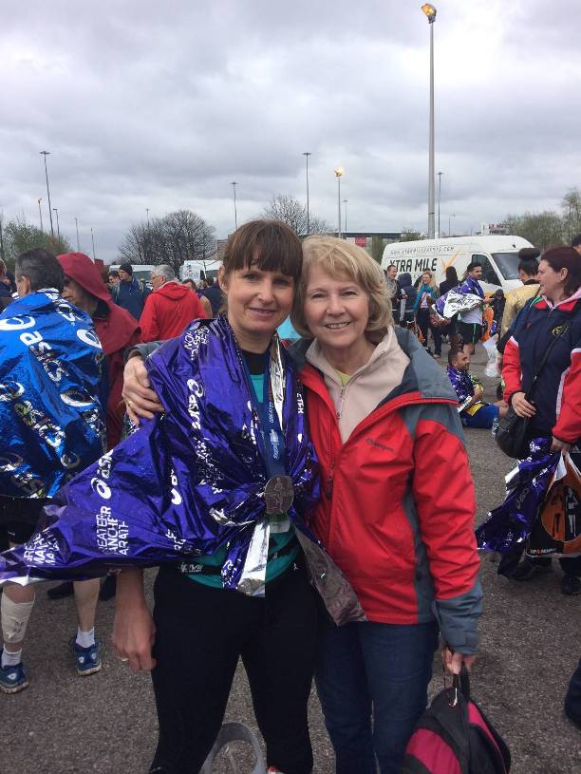
Eventually we made our way to the starting pens, conditions were fab considering it was forecast torrential downpours, Ron Hill started the race and we were off, the miles started to flyby and I felt really comfortable running just under 8 minute miling, wasn't sure how long this would last so thought if just carry on at the pace for as long as I could. I carried on feeling comfortable until around 21 miles when I could feel my left calf tightening quiet rapidly, I tried to block out pain and luckily the great crowds gave me that extra push to keep on at my pace. I managed to pass the 3.30 pace maker in mile 24/25 and it was dig in as much as I could.

I was overwhelmed to cross the line in 3 hrs 27 mins better than I could have imagined.

London Marathon

Ann
I was so excited about this event, and for me it was an event, not a 'race' or a 'run' - it was much more than that.

So shall I tell you about everything? Hey, for you, Linda - here's the full version ...

It starts the day before with the 'Expo' - where you collect your race number and then a thousand vendors try to get you to part with your money. It was late morning when we arrived and although it was busy it was impeccably organised and I had my race number and timing chip within three minutes of arriving.

And so did I head straight home to rest?? Of course not, true female that I am I said "consuming ... Bring it on!!” I expected to go into a mass spending frenzy and come out laden with all manner of trainers, socks, tops and other wonderful go-faster products. In reality after about half an hour we were all pooped, so we sat in the marathon lounge to listen to a succession of famous people talking about this and that while we ate very tasty noodles.

And so what did I buy I head your cry? Two recovery shakes!

Marathon day started with the same routine of porridge, honey and bananas and coffee then off to get the train to Greenwich. Follow the crowds ... Smiling marshals everywhere (they do smile in London sometimes), and then start the next routine of wait, queue, toilet, repeat until 10 o’clock. For the first time I decided to try the ‘female urinals’ - which meant a very long queue to get into a screened off area of grass with what looked like high plastic bins, and then a cardboard chute that you unfold, and, well, I must admit I was a bit intimidated by the whole idea, so just joined other ladies squatting the old-fashioned way … this was not my day for popping my urinal cherry, it seemed.

I actually saw Zoe! at the baggage lorry, as well as a pirate friend of mine (their yellow and black kit is very distinctive!), plus a lady who had travelled from Australia for her first marathon (I hope she had a good race).

The last toilet queue was very long and so my pen was full when I arrived, which meant that the 4 hr pacers were way up front out of sight, and even the 4:15 pacers were quite a bit in front of me. No matter, I have my Garmin, I'll pace myself.

The shuffle towards the start line only took 10 minutes and we were off. Even pace, the whole way - that was the plan ... If there was space, that is.

Mile one - the band. This was a marching university band from Huddersfield I'd read about ... Two years ago they set a world record for marching and playing during a marathon, and they were back to reclaim their record from the Germans - they needed to do it in 7:20 with no less than 30 second rest in between each piece. I did a little detour to go over to them and wish them well ... I can't imagine my band ever doing that!

Mile three (ish) the blue start meets up with the green start, and I'm holding my pace, but not easily. I knew a sub 4 run would be hard but I thought the pace would be easier than this. It was so crowded - you had to really concentrate to find your way through, especially having started at the back of my pen with the slower paced runners.

Straight arm man - literally no swing at all - how does anyone run like that?

Bottle terrain - there were water stations every mile which means a lot of bottles in the road. I managed to miss them all, but someone behind me landed on one and splashed energy drink all down my legs and my trainers were wet - oh the dramas, the trauma ...

Mile 6 (I think) - Cutty Sark - this was very striking, and the first taste of the crowds to come later. Big smile and wave for the camera.

Slow running - a combination of crowded narrow streets and me not concentrating meant a couple of miles were way too slow and this knocked my confidence, and really I spent a lot of the race trying to get it back. I'd banked some faster miles earlier but at my reckoning I was now 'in the red', pace-wise. "Ah well, I thought, perhaps you can make up the time later" (ha - did I honestly think that?!)

Mile 12 - Tower Bridge. Annette said she'd be here - it was rammed, wall to wall people, this was pretty awesome stuff, but spotting spectators in the crowd was optimistic at best (Annette - I did look!)... Keep running, Ann, keep trying.

Half way - a quick calculation told me I was few seconds off sub 2, but I was tired and really didn't believe, deep down, that I could maintain or in fact increase that pace for the test of the race. It wouldn't hurt to try, though.

Busy, busy, busy ... And very loud!

I knew the pirates (a group of triathletes from a runnersworld internet forum) had a support station coming up, and that two pirates had been allocated me to specifically look out for ... Nope - didn't spot them at all. Did that mean I'd miss Carol and Anders as well? They'd planned to be at Canary Wharf, but this whole stretch was just 5 deep in people - what chance did I have of spotting them?

Every chance, it would seem, as I came around the corner around mile 19 and there they were - good job Anders had his City top on! Quick hug and a kiss - Anders reminded me to remember the mantra “Hull, Ci - ty, Hull, Ci -ty” - he used to chant “bacon sandwich, bacon sandwich” to get him through Parkrun, but we decided to change it for the occasion.

I picked up for a bit after seeing my family, as did the noise of the crowd. By the time I got into the main part of London, the cheering was relentless - how can these people make so much noise? There must have been some very hoarse throats at work the next day!

The band - there’s a part of the route after London Bridge where it doubles back and runners are going in both directions … it was a this point the people on the other side were very slow, mostly walking, but behind this group were the marching band! Still playing! They looked very red indeed - I found out later on that they smashed their record and completed the marathon in 6:57
Keep going - I want to stop, lots of others are stopping, - no, don’t stop, keep going - this isn’t even half of what you’re doing in May, so man up and keep moving …

By the time I got into the 20s I knew sub 4 had gone but was pretty confident I’d still get a PB if I just kept going. I’d passed two 4:15 pacers, so as long as I kept them behind me, I’d be ok for a sub 15. Another 4:15 pacer caught me up, but I overheard him saying that he’d crossed the start quite a few minutes before me, so he was one I could ‘let go’. I don’t like pacers, I decided - early in the race they attract too many people so they are bunched up and difficult to pass, and later on it becomes a sort of love / hate relationship as I try to keep away from him, and then run with him, and then have to surrender and let him get away.

So just four or so miles to go, along Embankment and then Birdcage walk - here the crowds were almost more than I could bear - I started looking forward to a bit of peace and quiet at the end! I passed a lot of people on the floor with emergency blankets / stretchers / chairs, looking pretty poorly. It was really hot, in a non-sweaty sort of way. I was frequently pouring the rest of my water bottle over my head, and within just a few minutes was bone dry again. I did feel sicky and that I might collapse into the arms of a medic after passing the finish line. I’d felt better, but at this point I just imagined not being even half way to Brighton - man up, and get it done, do it for Daisy.

Bare bum man - at least let me get past him, this is not good for my morale.

I was determined to see the sights, (not naked sights) and I made the effort to marvel at the Tower of London, the Shard, Big Ben (I had been looking at the time quite a bit before I realised what clock I was looking at!), the London Eye, and then the Houses of Parliament, and then Buck Palace, of course - at this point I turn right for the Mall and there was the finish line - fab!

Having finished all I wanted to do was stay well, keep walking, and get to Wembley … and I did … and Hull City won that day as well - happy days!

Brid Easter 5 mile dash

Hayley
The Brid Easter 5 Mile Dash was my first race in a few years and I was really looking forward to it. The weather was perfect for me - glorious sun and a bit on the chilly side with only a very light wind. I met up with Jill and her sister (sorry can't remember her name) who were running and did a quick warm up before we waited for the start.

The route was lovely - a loop around the cliff top before heading into Sewerby Hall & Gardens. I remember reading in the route info that there was a steady climb up to the hall but the rest of the route was flat - maybe for experienced runners that is the case but I certainly counted several (little) climbs and although I've only done one hill training session last week, I felt the benefit and was quite satisfied to be able to keep running at my settled pace with ease. The other thing I recalled was Jane mentioning much of the route was on grass - not something I'm fond off but I coped better than I'd anticipated.

Between miles 3-4.5 the route was on a woodland trail with bark clippings underfoot and although the surroundings were lovely I didn't enjoy this stretch and at one point the "I might need to walk a bit" thought came into my head, however, I quickly banished this, ran up the very few steps that appeared in front of me, dug in and got to the last stretch back on the cliff top.

At this point I recognised a guy I used to work with a few years ago running on ahead of me (we had been in touch the previous night and he was telling me he expected to finish in 55/56 mins, my response had been "I'll be a good few after that"). So when I saw Steve you can imagine my thoughts!

I started to gather a little more pace and passed Steve and could see the finish line in the distance, next along the way was Jill with her super words of encouragement; I had a further short blast and finished in 53:45 feeling fantastic!

I can't wait for my next race and couldn't have done this one so comfortably without WHL - thank you all!

Huddersfield Marathon

Ann
And I thought Snowdonia was hard …

This event was to be my longest training run - my book tells me that doing half the distance in training should be enough for an ultra, and that any further and recovery knocks out too much subsequent training.

Therefore today I parked at my friend’s parents’ house, and her dad, also a runner, picked out a route about 3 miles away so that by the time I’d run the marathon and got back to the car, I’d have done 50km.

The website said the route was challenging, and they didn’t disappoint on that one. It’s a good job I didn’t check the elevation profile of the event until the night before!! I was afraid, very afraid; let me tell you - Achilles problems in both feet, two weeks out from a PB at London marathon, barely any miles in between apart from walking … and then the hills, the distance …

… but my friend Rebecca was at the YMCA when we arrived, which touched me, because she’s a very busy person. Registration was very straightforward - we stood about for a bit, ate her partner’s home-cooked energy bars (with chia seeds, I tell you!!), and then we ambled onto the playing field for a couple of minutes and then we were off.

Within seconds the field took off, and I daren’t look behind me to find out I was the last one … surely not last …? I trusted there must be at least someone behind me, and if there wasn’t, there would be, because someone speeding off there in front of me has just made a biiiig mistake with their pacing …

So I relaxed and looked for a running partner. A chap with a big beard and a big rucksack overtook me, and then I caught up with him, and decided not to be put off by the beard. This was a good decision, as he was a normal chap, and we ran together for quite a while. Chat went the usual way - ‘done this before’?, ‘have you done other marathons?’, ‘what events have you done / would like to do?’ This helped to stop me fretting about these damned hills for a while … but then they came - up and down, up and down, and then a very big down - my quads were hurting and I’d only just started, so I’m wondering just how much this is going to hurt the second time around. This was followed by the mother of all hills (well it seemed that way to me). We could see it from the opposite valley, and we could also see the camper vans crawling up it …

… time to walk … and overtake someone, who had trousers on!! (Where do these runners come from?!!) and walk, and walk, and eventually the up became flat and then another down … and that was the pattern for the marathon, although the ups and the downs were probably worse at the first half of the loop, north of the M62, and then after a short path alongside the motorway, the second part of the loop was south of the motorway, and was more residential, and whilst still hilly, didn’t feel so extreme.

By this point man with beard had pulled away and my new running partner was a lady called Terry (pronounced ‘Teary’). Terry had done 40 marathons! She was great to run with, because she was a) Very polite and b) very simplistic about her running - she trained on a treadmill, wore cotton tops, stopped at a pub for a toilet visit, carried a bottle of water and a bag of jelly babies in her hand, and put on a velour hoodie when it got windier later. I was intrigued how someone could have completed so many marathons and not know where a quad was. I love the diversity about running!

Terry and I ran and walked and talked, and bit by bit the miles drifted by. By the time we finished the first lap I was feeling far happier, knowing that the hills didn’t destroy me, and that the likelihood was this would be another successful finish.

And it was … 5 hours and 35 minutes later we both crossed the line and then hugged and said ‘goodbye’. It’s funny - I learned so much about my friend and the chances are I may never see her again … there’s another thing to love about marathons - especially those ones when you’re not tearing around the course trying to be faster than you’ve ever run before.

My lovely friend had not only met me at the beginning, she’d hung around the course for both laps, and then went to the end to see me finish, and - get this - had bought me a bottle of Lucozade! How kind was she?

So that just left the run back to my friend’s parents’ house. So … down the road and left, then right at the bus shelter … rem … this shelter? another shelter? This doesn’t feel right at all … keep moving, maybe you’ll see something familiar … Right, so I’m stuck in the middle of Huddersfield, I’ve run nearly 30 miles and I’m lost. As it happened, once I’d asked directions I wasn’t that far away - just another humungous hill to climb and one field to cross to back.

The funniest part of the day was my attempt to climb the stile into the field. I got my first leg over, but the other leg did not want to conform, and as I was wearing shorts, I couldn’t even grab my trouser leg to pull it over the stile. In the end I had to sort of lean over and then drag the remaining leg over the stile. I was so pathetic, it really made me smile!

Job done - 50km = 31 miles. Its two days later I am writing this, and my quads are still hurting more than they ever have before! Would I do it again? Not for the medal - this was hardly worth having, but the atmosphere was actually lovely. For a first event, it was well signposted, really enthusiastically supported by the volunteer marshals, and, well - just nice, in a sick, painful sort of way!

Worcester Marathon

Ann
I should have written this report on the same day, but as you’ll see later, I got a bit distracted after the race …

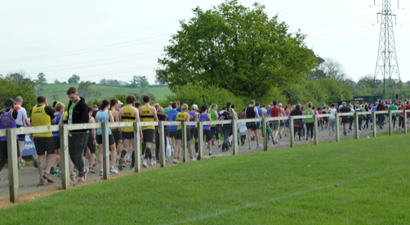

We (Dad and I) arrived far too early, so time for me to queue, loo, queue loo, and say ‘hello’ to the three gorgeous golden retrievers hanging about - I think they were the race director’s. We managed to find a picnic bench to sit at, that was sufficiently far away from a very loud local radio station van. It added a bit of atmosphere, I suppose, but Dad was not impressed!

A short 5 minute walk to the start point, and then an inexplicable 15 minute late start and we were off - uphill. And thus it continued for 26.2 miles, it felt to me.

I don’t want to sound moany, but I don’t remember many downhill sections, just a lot of uphill walking sections, which secretly I quite liked, because I’m ‘allowed’ (according to the rule of Holmes) to walk the uphills. I must have done some running, though, because I remember that it hurt in different places to run than to walk, so I must’ve done both.

I really wanted to reign myself in for this one, and intended doing a lot of walk breaks at water stations, and the like, but I did find myself running more than I thought I ought to, and wondered whether I was making a rod for my own back with another marathon the following day. Still it felt wrong not to run when I was able, but since I was pretty uncomfortable a lot of the time, I figured aiming for 12 minute miling as an average would be ok.

This is not a city marathon - it doesn’t even start in the city, but at a rugby stadium north of Worcester, and the entire two lap route was along country roads of Worcestershire - very pretty and very quiet. This was apart from the marshals, who, as is often the case, were full of beans and very encouraging (Blackpool marathon being the exception to this rule!).

It was lovely to see my dad at a couple of points along the route - I was really touched that he had learned the entire route and had already decided where he would be. He’s not a very demonstrative man, but it touches me deeply when I ‘catch’ him being so loving like this.

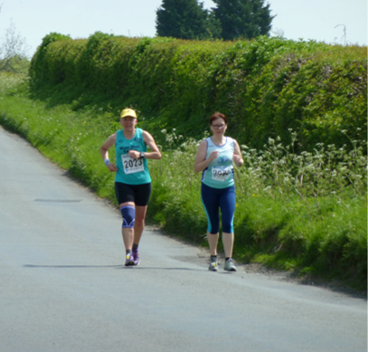
Running at the pace I was running at meant being with athletes either doing their first marathon, or later on in the race, with those who went out too fast at the beginning and now their wheels have come off. It’s difficult passing these people, as I don’t know what to say when they’re clearly in a world of pain and face 8 more miles of walking. The beginners, though, are good to run with - I met a lady called Dawn, who was being very down on herself for not doing her first marathon in under 5 hours - I did my best to boost her up a bit, and to encourage her - when I left her a couple of miles later she said I’d really helped - I like that.

Dad and I were visiting his other two sisters after the race, and my Aunty Pauline was feeding us too, so I was conscious of getting back in time for this. When I finished, though, I realised that it being so late in the race there probably wouldn’t be a queue for a massage, and with Milton Keynes the next day, I figured I’d just have enough time to squeeze one in before we headed off to the Cotswolds.

Shoes were removed upon entry, so I put my trainers in my bag and asked Dad to look after it while I was having my massage. A few minutes later, Dad realised that the bag had gone - he’d looked away for just a short moment, and it had disappeared - my phone, purse, my beloved pirate kit, and more importantly - my Snickers bar, no, I mean - my trainers!

There wasn’t much to be done, other than to report the loss to the race organisers, which Dad did, and then on the way to my aunty’s, to cancel my cards and my phone, and, well - get over it. At least it meant tomorrow’s crazy two marathons in two days idea was off, as I had no trainers to run in. I was quite relieved, really, as I was dead tired.

When we finally got home later that evening, imagine our surprise when there was a phone message from the race organiser to say someone had picked it up by mistake and was profusely sorry - so he should’ve been - what a silly sod … excuse my French, but really - it’s not rocket science, is it?

So the problem then was that my bag was now down in Gloucester, and it was eight o clock. The race organiser had agreed to pay the postage for it to be sent to Hull, but in fact when I rang this numpty chap, he was so sorry that he got in the car and headed straight up the motorway to meet us and hand it over.

So alas, tomorrow’s race was back on - gulp!

Milton Keynes Marathon

Ann
It’s a long way to Milton Keynes from Redditch (my dad’s house) - longer than I’d realised originally, so I was up at 6.30, and on the road an hour later - good job, because went the wrong way a couple of times, and then the final roundabout at Milton Keynes was rammed. ‘No worries’, I said to myself - ‘its chip timing, so you can just start when you’re ready’. In fact the traffic jam meant that once I’d parked and handed my bag over, there was just time for a quick toilet visit (no queues - can you believe that?) and then a gentle amble over to the start line, and 10 minutes later we were off.

The first few steps were a bit scary - how much will this hurt … not that much, as it happened, so I carried on running.

I’m beginning to think that I can predict how a race will go within the first ten minutes - its felt like that at the Great North, as well as at London three weeks previously. Today I felt good from the start and that feeling never went away. I checked the elevation data the night before and it wasn’t much different to Worcester, only this race I seemed to run down the hills more noticeably than I ran walked up them.

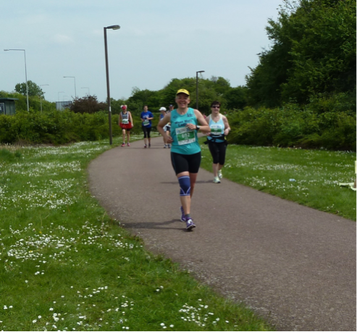
As yesterday I started conservatively, which again meant running back of the packers - it was funny, I lost them all when I slowed to a walk on the hills and they carried on running, but later on passed everyone I’d chatted to earlier! There was the Vegan runner from North London, a lady running on the 5 hour pacer ‘bus’, and the girl that had her Outlaw T-shirt on, so we shared our experiences of our first Ironman. I also chatted to some of the 100 Marathon club runners - I’m starting to get to know some of these faces now as they are repeatedly turning up to the same races as me - including Jagjit, who I met at Northamptonshire marathon. His last race was at the Arctic - it’d cost him thousands of pounds!!

Milton Keynes is under-rated. Its streets are very regimented, and the first part of the route had a lot of out-and-backs down streets that all looked the same, but the entertainment was great - a rock band, a couple of samba bands, a fabulous skiffle band and two belly dancers! The second part of the marathon was even better. After the half marathon people had peeled off back to the stadium, the rest of the route went on the ‘Redway’, which is a whole network of wide paths for pedestrians and cyclists. These paths were often tree-lined, and went past residential areas, wooded areas, lakes and play areas - and dotted throughout the route were very committed marshals and wonderfully enthusiastic supporters. I couldn’t stop smiling - the people of Milton Keynes are just fab - they kept telling me I was doing so well, so I told them they were, as well! I can’t emphasis what a difference this crowd made - I was running well anyway, and was so relieved and happy that my legs were working, but these supporters just made me smile so much. This race was so enjoyable.

Milton Keynes marathon is not a PB route, but if anyone wants a marathon that’s a good day out with a great atmosphere and supporters who genuinely want you to do well, then I would recommend this in a heartbeat - it was a fabulous day out

… and I ran it faster than yesterday!

Driving home I was listening to Classic fm, and they played the Dambusters march - I love this music, we play it in our band - I was feeling so proud and happy, so I turned up the volume, grinning from ear to ear, but filling up … then my thoughts turned to Daisy - she was the reason I was doing this .. and wept … and I’m crying now …

Thank you so much for so much encouragement and support, and donations - I think I’m ready for London 2 Brighton now - so bring on the taper, my sofa awaits!!

www.justgiving.com/daisyholmes

Confessions of an Over-Pronator by Clare

Well, I didn’t realise how important one pair of trainers could be for a runner.

As most of you know I started with the 0-5k ladies in January and suddenly my obsession for running was there after the first week. I had some fabulously looking snazzy Reebok squiggly trainers. I thought I looked a right bobby dazzler in them. At about week 3 of my new professional running career I started to experience numbness in my left foot. It didn’t happen all the time but more so for the longer runs. As I am a determined East Hull bird (newly West Hull bird) I carried on running when I couldn’t feel my foot.

This numbness came and went and along with my new friends, I completed the course. Then I fell victim to a 5 miler. This was my longest run and I felt I was running strong at the 2 mile mark. After that it was just pain and tightness in my left leg/foot. Again as we have already determined earlier in this story I was an idiot and kept running. That was the last run I did for about 3 weeks. My ankle was just too painful to run and walk on it. The torture of not running, struggling to move for my badminton matches and pure pain of feet in ice buckets led me to the door of Jamie Barrington.

Before he even looked at my feet he took one look at my shoe tread and said I was an over-pronator. After walking up and down the room, testing my lack of flexibility and establishing my feet are wonky, he recommended that I get new running trainers asap, new shoes to walk in (strangely I under-pronate when I walk), stretch every time compare the meerkat advert comes on the tele and shove my club feet in a bucket of cold water (not ice) every hour – yes I know slightly unrealistic but I was determined to still give it a good go.

So stretching, watering and cross training (gym) I was determined to get back running with you gals’.

My foot was starting to feel a little better so I joined the ladies on their first 10k one Wednesday night. My intention was to run a mile then run back making it 2 miles. Well I felt really good and I thought “you could possibly do this” after we gathered up at 1.5 miles. Then Sarah W saw me contemplating the 10k after no running in 3 weeks and quite rightly made me run a 4 miler with Beryl and Mandy. It was so good to be running and I didn’t struggle like I thought I would.

So I was starting to feel better and did a park run. It was tough but I managed to do it. I had this fear that if I stopped running for longer than I had then I would fall behind and would be back to square one again. For those that may remember I was actually a member of WHL ladies last year for about 2 months before I injured my ankle (what a surprise).

It was then fate that Rachael sent an email to everyone about having our gait analysis done at Humber Runner. What they showed me really highlighted why I have been agony. Take a look at the picture of my foot. The foot on the left is my old trainers and the one on the right is my new trainers. I am quite a bad over-pronator. So bad in fact that they will be using my video in crap (no longer snazzy) trainers to demonstrate to people that it is important to run in the right trainers for you. I think I should be commission for the amount of money they will make off my dodgy feet.

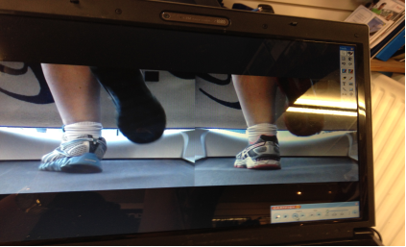

Can you see how my new trainers straighten my foot now? Looks quite painful doesn’t it.

Previously I had always gone on style over substance which has been the cause of many of my feet issues.

So in my new trainers I have managed to run 10k with no pain in my foot. I have been back to Mr Barrington and after being subjected to his torturous calf massage and pressure points (on my gluteus maximus!! I have a bruise still) he says the difference is great. I need to stretch and water after running or exercise but there is a great improvement.

So the morals of my story:
- Stop if it’s painful
- Don’t over train
- Stretch a lot
- Make sure you have proper footwear!!!!!!!!!!!!!!!!!!

Flapjacks/Nutrition Bars

INGREDIETNS

- 2 tbsp golden syrup
- 4 tbsp runny honey
- 150g/5oz salted butter
- 100g/3 ½ desiccated coconut
- 150g/5oz porridge oats
- Handful any dried fruit
- Handful any nuts
- 2 scoops protein powder

PREPARATION METHOD

- Preheat the oven to 180D/350/Gas mark 4
- Grease a medium baking dish, line with greaseproof paper and grease the paper as this will help to remove the bars after cutting (see 8 below)
- In a large saucepan melt the butter, golden syrup and honey together in a low heat stirring until well combined
- In a food processer blend the oats, nuts dried fruit, coconut and the protein powder, blending will help with binding during cooking
- Mix all the dried and wet ingredients together until all is well combined
- Pour the mixture into the prepared and lined baking dish press down into the corners until all is evenly spread
- Bake for 25-30 minutes or until golden brown
- When cool pick up the corners of the greaseproof paper to lift out of the dish and rest on a wire rack, cut into squares and put in a box in the fridge to last about a week

Racing and Running Events
Fancy something different? For worldwide marathons click here

Date/Time | Event | Fee | Entry forms | Online entry
May 2014
25th/11:00 | Driffield Mucky Duck (Multi-terrain) | £10 UKA/£12 | Entry form | Online entry
June 2014
1st/11:00 | Humber Bridge 10K | £11 UKA/£13 | Entry form | Postal entries only
8th/09:30 | Jane Tomlinson Hull 10K | £26 UKA/£28 | Online entries only | online entry
15th/11:00 | Burton Pidsea 10K | £8 UKA/£10 | Entry form | Online entry (+£1)
22nd/09:30 | Jane Tomlinson Pennine Lancashire 10K | £16 UKA/£18 | Online entries only | Online entry
29th/09:00 | Humber Bridge Half Marathon | £20 UKA/£22 | Entry form | Online entry
July 2014
11th/10:00 | Walkington 10K | TBC | TBC | TBC
20th/09:30 | Jane Tomlinson Leeds 10K | £26 UKA/£28 | Online entries only | online entry
August 2014
3rd/09:30 | Jane Tomlinson York 10K | £26 UKA/£28 | Online entries only | online entry
20th/08:00 | LDWA Smugglers Trod | £10 | Entry form | Postal entries only

Please remember to double check dates, times and entry fees with the official website or the entry form.

www.westhullladies.org.uk/races.htm Zoe, Racing Officer

NOTE: Club Vests must be worn at any races you enter
under the West Hull Ladies running club name.

West Hull Ladies Road Running Club
Kit Order Form

FORENAME ___________________________________

SURNAME ___________________________________

ORDER - tick what you require, with size Price

- VEST SIZE ___________ £16.00
- LONG SLEEVE TOP SIZE ___________ £18.50
- BEANIE HAT £6.50
DATE Ordered _______________

AMOUNT PAID _______________

Please transfer payments online with your name and marked as ‘Kit’ to:
Account: 63762742 Sort Code: 20 43 49.
Or cheque payable to ‘West Hull Ladies RRC’, and write your name and ‘Kit’ on the back and give to Club Treasurer Debbie Watson, 51 Westbourne Ave, Hull.

Sign on receipt of goods _________________________________

DATE _______________

Please complete this form and email to diazmaria@btinternet.com

Thanks.
Maria
Kit Officer

